Photo of Portable Heater: |  |  | Make:
 |  |  | Model:
 |  |  | Serial No:
 |  |  | Location of use:
 |  |  | Trainee/Authorised Person:
 |  |  | Trainer/Manager:
 |  |  | Date:
Safe Operating Instructions for Portable Heater Users
As an Authorised user of the portable heater named above, you must adhere to the instructions below.

Before each use, visually inspect the heater, plug, and cable for damage, scorching, fraying, or loose wiring.

Check for any signs of overheating on the plug, cable, or casing, or any strong burning smells.

Do not allow unauthorised persons to use the portable heater.

Keep the portable heater locked away or restricted so that unauthorised persons cannot access it.

Inspect for dust build-up or blockages in air vents – keep the heater clean and dust-free to prevent overheating.

Do not position it in an area where it could be easily damaged, such as walkways or other busy areas.

The heater must be positioned on a flat, stable surface and kept at least one metre away from combustible materials such as paper, cardboard, furniture, or bins.

Never place heaters under desks or in confined spaces where airflow is restricted.

Do not cover the heater or use it to dry clothes or other materials.

Ensure adequate ventilation in the room when the heater is in operation.

Do not move or handle the heater while in operation or when hot.

Heaters must be plugged directly into a fixed wall socket – extension leads are not permitted.

Do not use the heater near water sources or where flammable vapours, aerosols, or gases are present.

Report any faults, damage, or operational issues immediately. Faulty heaters must be taken out of service.

All operation, cleaning, and maintenance must follow the manufacturer’s instructions.

When the heater is no longer required, it should be removed from the area and stored safely.

Heaters must not be left unattended and must be switched off when not in use or when leaving the room / area.
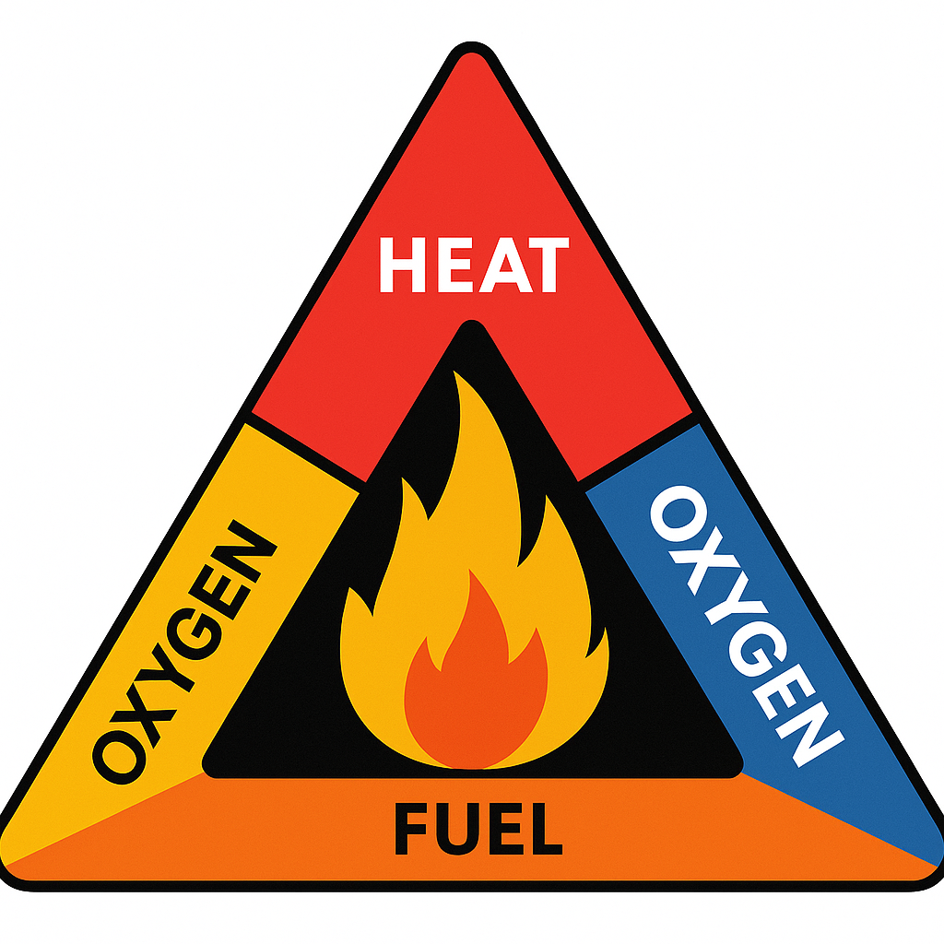
When using portable heaters, remember the fire triangle - heat, fuel, and oxygen. A heater
provides the heat, so to prevent a fire you must control the fuel source by keeping
combustibles such as paper, cardboard, or furniture at least one metre away, and ensure
good ventilation to avoid heat build-up. Removing any one side of the triangle prevents a fire from starting.

Confirmation and acceptance
I, the trainee and authorised person, understand that my employer is authorising me to use a portable heater and that I will operate it in accordance with the manufacturer’s guidelines, which I have access to, and the instructions set out in this document. I understand that I must seek further guidance from management if I am unsure at any time.
Authoriser name: |  | Signature: |  |  |  | Date:
Authorised person / trainee name: |  | Signature: |  |  |  | Date:

